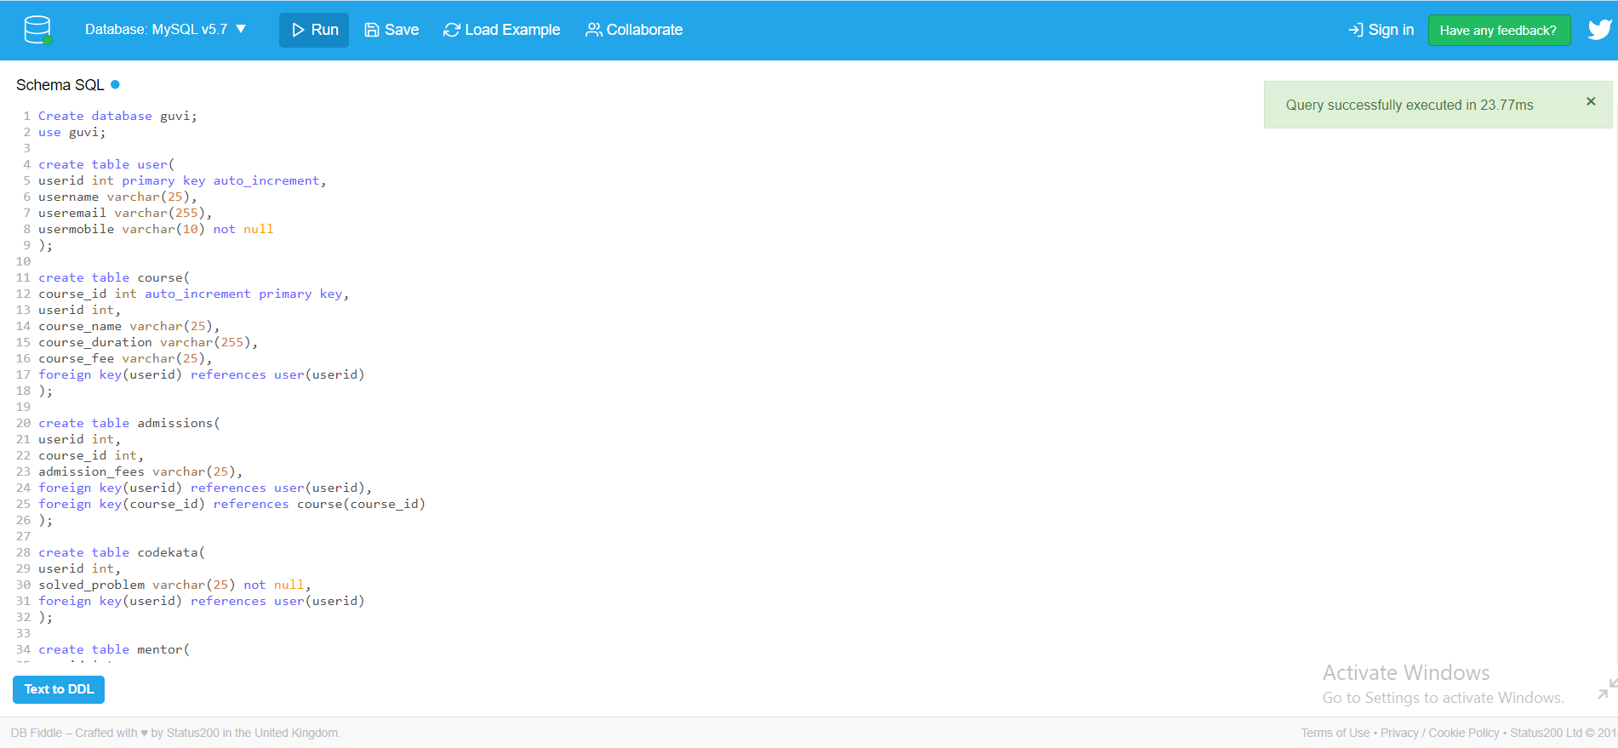

Create database guvi;

use guvi;

create table user(

userid int primary key auto_increment,

username varchar(25),

useremail varchar(255),

usermobile varchar(10) not null

);

create table course(

course_id int auto_increment primary key,

userid int,

course_name varchar(25),

course_duration varchar(255),

course_fee varchar(25),

foreign key(userid) references user(userid)

);

create table admissions(

userid int,

course_id int,

admission_fees varchar(25),

foreign key(userid) references user(userid),

foreign key(course_id) references course(course_id)

);

create table codekata(

userid int,

solved_problem varchar(25) not null,

foreign key(userid) references user(userid)

);

create table mentor(

userid int,

course_id int not null,

mentor_name varchar(25) ,

foreign key(userid) references user(userid),

foreign key(course_id) references course(course_id)

);

create table studentsAttendance(

Attendance_id int,

userid int,

Attendance_date datetime default now(),

status boolean default true,

foreign key(userid) references user(userid)

);

create table task(

userid int,

submited_task varchar(25) not null,

task_mark varchar(25) ,

foreign key(userid) references user(userid)

);

create table leaderboard(

userid int,

course_id int,

batch varchar(25) not null,

submited_task varchar(25) not null,

foreign key(userid) references user(userid),

foreign key(course_id) references course(course_id)

);

create table queries (

userid int,

topics varchar(2000),

reasons_queries varchar(2550),

foreign key (userid) references user(userid)

);